LAB 1

Objective: To study and simulate the behaviors of different trigonometric functions using MATLAB/Simulink. (Any three.)

Theory
Trigonometric functions are fundamental mathematical functions widely used in engineering, physics, and simulation systems. In simulation and modeling, these functions are used to represent oscillatory motion, waveforms, and periodic signals.
- Sine Function (sin)
  - It is a periodic function.
  - Range: -1 to +1
  - Period: 2π radians
- Cosine Function (cos)
  - Similar to sine but phase-shifted by 90° (π/2 radians).
  - Range: -1 to +1
  - Period: 2π radians
- Tangent Function (tan)
  - Defined as tan(x) = sin(x) / cos(x)
  - It is periodic but has discontinuities where cos(x) = 0.
  - Range: (-∞, +∞)
Using Simulink, these functions can be modeled using built-in trigonometric blocks and visualized using scope blocks.

Procedure
- Open MATLAB software.
- Launch Simulink from the MATLAB command window.
- Create a new blank Simulink model.
- From the Simulink library browser, add:
  - Source block (e.g., Clock or Sine Wave)
  - Trigonometric Function block (set to sin, cos, or tan)
  - Scope block
- Connect the blocks properly.
- Set simulation parameters such as time duration.
- Run the simulation.
- Observe and analyze the output waveform in the Scope.
- Repeat the steps for sin, cos, and tan functions.

Diagram
- Sine Function (sin)

- Cosine Function (cos)

- Tangent Function (tan)

Output
- Output waveform of sin(x)
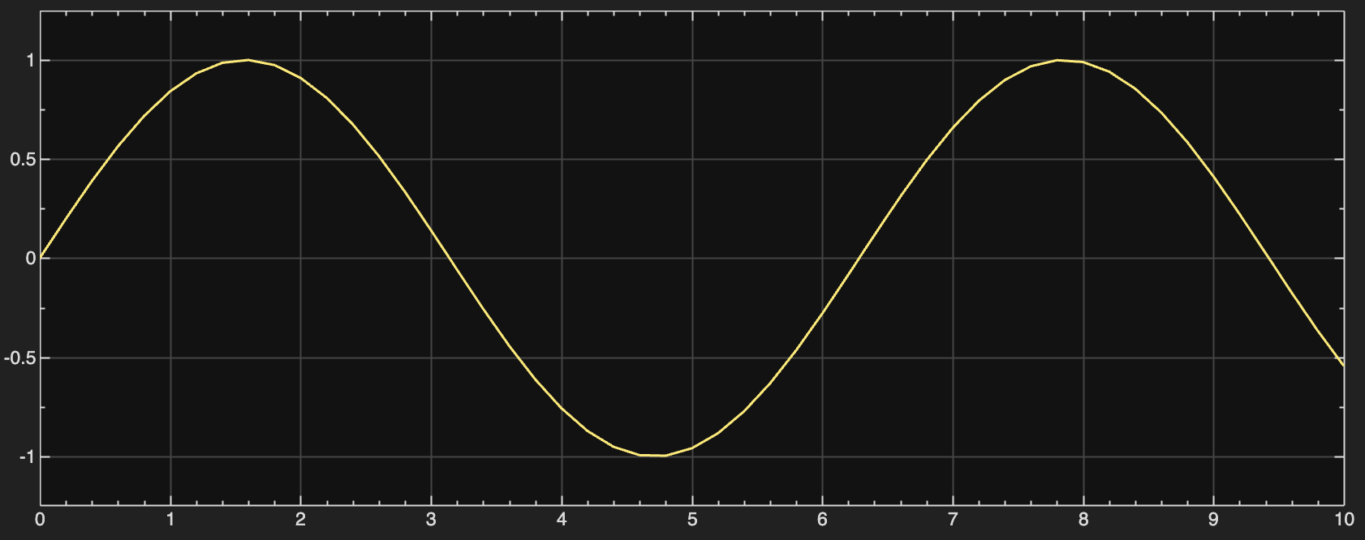
- Output waveform of cos(x)
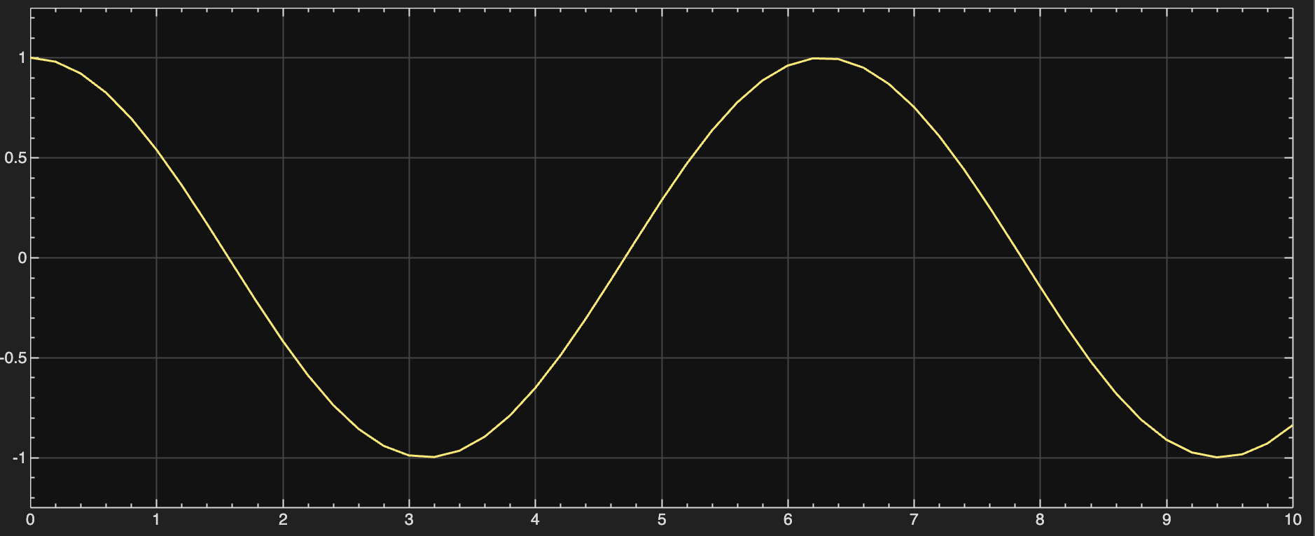

- Output waveform of tan(x)
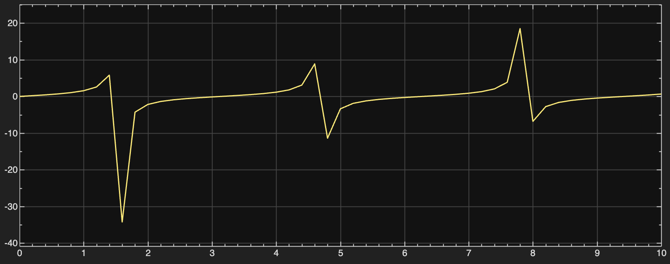

Result
The simulation of trigonometric functions using MATLAB/Simulink was successfully performed. The sine and cosine functions showed smooth periodic waveforms, while the tangent function showed discontinuities at specific intervals. The results matched the theoretical behavior of the trigonometric functions.

Conclusion
From this experiment, we learned how to model and simulate basic trigonometric functions using MATLAB/Simulink. This experiment helped in understanding the behavior, periodic nature, and graphical representation of sin, cos, and tan functions, which are essential in simulation and modeling applications.

